Sediment Contamination
Name
Institutional Affiliation
Sediment Contamination
Notably, grain size (also known as Particle size) is the individual grain diameter of sediments. In this case, different sediment grain sizes from different types of rocks. For instance, various types of grain size hugely contribute to the formation of different sediments. It is prudent to note that their varying forms of erosion authentically classify sediments as either being chemical or clastic. Through corrosion, the chemical sediment is further broken down subsequently through chemical weathering that incorporates transportation now. Additionally, the chemical sediment is critically suspended in a solution until precipitation. In other words, due to exposure of the solution to high temperatures through the sunrays, the solution evaporates thence leaving behind the precipitate that is depicted now as chemical sediment.
Similarly, there are clastic sediments that are broken down through mechanical ways. For instance, the sediments form as a result of abrasion from the wind, ice or even water (Krishna & Mohan, 2013). In reality, clastic residues include but not limited to sand, clay, and silt. Also, these sediments profoundly depend on physical, geological forces to enhance their formation. On the same note, it is quite evident that the sediments differ in terms of size, regardless of being of the same type. For example, in spite of sand being formed; as a result, abrasion of the wind and water, it is clear that the sizes of the sand particles critically differ. Therefore, it is quite evident that the real strength of the wind and waves of water play a circumspective role in determining the kind of sand particles that are to be formed.
Besides, various grain sizes form sediments. Gravel geographically forms rocks which are coarse with a grain size of 2mm (Alomar, Estarellas & Deudero, 2016). Retrogressively, conglomerate is created if the fragments are rounded. On the other hand, when the particles are angular, they tentatively form breccias. As distinct, sand forms sandstone that is medium-grained in size thus having a fragment that ranges between 1/16mm to 2mm. Therefore, anything that is below 1/256mm purely results to either being mudstone (argillite and shale or claystone) or shale.
Moreover, contaminants are generally the unwanted particles that are carried alongside these grains. The concentration of sediment contaminants shows an inverse correlation with the grain size (Rozenstein et al., 2014). Therefore, through this inverse correlation, difficulties arise in the actual process of distinguishing real differences concerning contamination from various artifacts that are caused by variations in the texture of sediments. To avoid the problems in ascertaining the specific concentration levels of contaminants in multiple residues, regression analysis is anonymously used. Geologically, the particle grain dimension is an essential indicator of the quantity of contamination. In this case, it can be noted that the larger the size of the grain, the higher the possibilities of the grain being contaminated.
Further, sand or soil contamination, in general, leads to land degradation. Soil contamination, in general, is caused by xenobiotic (human-made) components in the soil (Krishna & Mohan, 2013). In addition, chemicals that are disposed of carelessly thence reaching and contaminating the earth cause soil contamination. Equally, some minor causes of soil contamination are the natural environment of the soil in the soil, for instance; too much tillage. To note, high usage of farm chemicals (fertilizers) has great chances that subsequently lead to soil contamination. On the same note, industrial activities, also, lead to soil contamination. For instance, the soil is contaminated through industrial spillage of wastes into the ground. In this case, it is evident to note that different soil particles are differently prone to contaminants. For example, clay and sandy soil are highly susceptible to containing pollutants like hydrocarbons and other forms of polynuclear aromatics (naphthalene, pesticides, and lead).
When assessing metal contamination, it becomes self-evident that the contamination distribution of the contaminants dramatically differs according to the size of the grains. For instance, in surficial sediments, comparing the research conducted by North America Ecology Department in Mississippi, clearly authenticate that sand has Lead (Pb) contaminant of 33 mm/kg in the sand while clay has 27 mm/kg of the pollutant (Alomar, Estarellas & Deudero, 2016). At this state, it is evident that the result depicts that the actual size of the grain sediments plays a crucial role in determining the level of contamination of the soil. Further, it can be noted that due to the high levels of Lead contaminant and other contaminants in general, soil fertility reduces and hence not able to sustain farming regardless of the availability of water.
The aqueous/soluble concentrations of contaminants (heavy metals) in the sediments are frequently governed and controlled by the actual precipitation and dissolution of the discrete mineral phases. In other words, contaminant transport in the natural systems occurs when the contaminant is authentically soluble in the particular sediments (Alomar, Estarellas & Deudero, 2016). Thus, thermodynamic solubility of contaminants that contain minerals directly influences the reactivity of chemical, ecotoxicity, and transport of their ions. The Lead (Pb) contaminated sediments contain the anglesite minerals (POSO4), cerussite (PbCO3), and other oxides like PbO and even litharge. In addition, there are cases whereby Pb2+ is soluble in the soil and adsorbed as Mn (hydroxides) and Fe. There are cases whereby the adsorbed Pb becomes inert or forming lead oxides, carbonates, and even sulfates hence hugely soluble in circumneutral and acidic environments. The Lead (Pb) in the soil poses a significant threat to the environment. On the other hand, the phosphates of Lead, for instance; Pb5(PO4)3 and pyromorphite are not such soluble and geochemically stable over a vast range of PH. Soil contaminants have been altered over time now, courtesy of human activities thence increasing their toxicities and the actual rate under which living organisms approach them.
It is quite evident that different grain sizes have different capabilities concerning the transportation of sediments. First, sediments can be described as the conglomerate of inorganic and organic materials that can adversely be conceded by water, ice or even wind. Commonly, the deposit has its traces in mineral matter, which in this case includes silt, clay, and sand. On the same note, the decomposing inorganic and organic materials are tentatively referred to as sediments (Rozenstein et al., 2014). Additionally, most organic residues come as a result of weathering and erosion while mineral deposits arise as a result of decomposing and detritus materials that include algae and fungi. Therefore, sediments have different manifestations, taking into critical consideration the actual amount of organic and inorganic content that contributes to its composition.
Particulates are quite small whereby clay is tentatively defined to be the lowest in terms of size since its particles have a diameter that does not at any moment exceed 0.00195mm (Rozenstein et al., 2014). On the other hand, and has the largest diameter that does not go below 1.5mm for width. However, it is wary of noting that during high water flowing episodes like floods, even the assumed large rocks could adversely be classified to be sediments, simply because they are also carried downstream. In addition, the rocks can be organized to being sediments during flooding due to the policy that “sediments are natural elements that occur in huge water bodies, whereby the anthropogenic factor influences the.” Gravel, sand, silt, clay, and algae form the best part of sediments.
In the aquatic environments, sediments can, on the one hand, be suspended, floating on top of the water body, or even bedded under the water body (Akcil, et al, 2015). In other cases, when both bedding and floating occur, then Suspended and Bedded Sediments (SABS) occur. Fine sediments (clay) are found in almost every water body, being drawn along by the flowing water. When deposits are floating inside the column of the water, then the sediments are depicted to being Suspended Sediments or Suspended Solids. In this case, the actual difference between Suspended Sediments and Suspended Solids is the real method of measurement that is used to measure the textures of the two.
Nevertheless, regardless of the similarity in the denotation meaning of the two sediments, the official data that is ascertained through these different measurement approaches are neither comparable nor interchangeable (Alomar, Estarellas & Deudero, 2016). In other words, the Suspended Sediment Concentration (SSC) is calculated through mg/L by filtration and drying up the whole water taster. On the other hand, Total Suspended Solids (TSS) are also calculated in mg/L but are acquired through subsampling. The TSS measurement is related to highly elegant and homogenized samples thence excluding larger particles that are suspended during filtration. The SSC measurement has a tendency to be relatively higher and an adequate representation of body of water. The SSC measures with a range of 5 percent of the particle concentration.
Sediment transport also known as sediment load refers to the actual motion of inorganic and organic particles by water. In wide-ranging, when the flow of water is high, consequently additional sediment is transmitted. When water flows with maximum strength, it is clear that more particles are suspended in the water columns as they frequently move downstream (Zhao, Wang & Li, 2017). In other cases, the sediments are drastically pushed along the bottom of the water path. Transported sediments include but not limited to mineral matter, pollutants and chemicals, and organic matter. The total load encompasses all particles that are advancing as bedload, wash load, and suspended an amount.
Holistically, bedload refers to the actual segment of sediment transport that slides rolls or even bounces that are along the underneath of the waterway. The sediment is not such hovering since upholds intermittent association that it makes with the streambed (Akcil et al., 2015). Besides, it can be noted that movement is neither continuous nor uniform. In most cases, bedload occurs when the water forces are active, in that, they are adequate to sustain the sediment cohesion and weight. Statistically, bedload transportation can tentatively happen at low flows that incorporate quite smallest particles or even at elevated tides for larger particles. In approximation, 5-20% of the entire sediment transfer is automatically bedload. Equally, in conditions whereby the rate of water flow is relatively steady, portion of the smallest bedload particles can further be pressed into the water columns thence becoming suspended.
There is a clear distinction between the Suspended sediment and the suspended Load. Hovering sediment are constituents that are located in the column of column, regardless of the water streaming or even not (Zhao, Wang & Li, 2017). On the other hand, the suspended load is the actual amount of sediments that are taken downstream with the columns of water, courtesy of the flow of water. In this case, it is essential to depict that Suspended loads critically necessitate flowing water, whereby as the water streams it generates currents upstream, a form of turbulence thence keeping the particles in motion. In suspended load, the large particles in the water column adversely fall when the flow rate of the water reduces hence subsequently reduce the motion-enabling currents for the sediments.
In conclusion, for people to practice agribusiness globally there is a need for the first to study the kind of sediments and contaminants that surround them. Critical componential analysis of the different soil types must be purely conducted to ascertaining the best practice for specific soil types. Above all, the size of the sediment grain size plays a circumspective role in determining the level of contamination.
References
Akcil, A., Erust, C., Ozdemiroglu, S., Fonti, V., & Beolchini, F. (2015). A review of approaches and techniques used in aquatic contaminated sediments: metal removal and stabilization by chemical and biotechnological processes. Journal of Cleaner Production, 86, 24-36.

Alomar, C., Estarellas, F., & Deudero, S. (2016). Microplastics in the Mediterranean Sea: deposition in coastal shallow sediments, spatial variation and preferential grain size. Marine environmental research, 115, 1-10.

Krishna, A. K., & Mohan, K. R. (2013). Metal contamination and their distribution in different grain size fractions of sediments in an industrial development area. Bulletin of environmental contamination and toxicology, 90(2), 170-175.
Rozenstein, O., Zaady, E., Katra, I., Karnieli, A., Adamowski, J., & Yizhaq, H. (2014). The effect of sand grain size on the development of cyanobacterial biocrusts. Aeolian Research, 15, 217-226.
Zhao, H., Wang, X., & Li, X. (2017). Quantifying grain-size variability of metal pollutants in road-deposited sediments using the coefficient of variation. International journal of environmental research and public health, 14(8), 850.

Appendix:
- Sedimentary Rock.
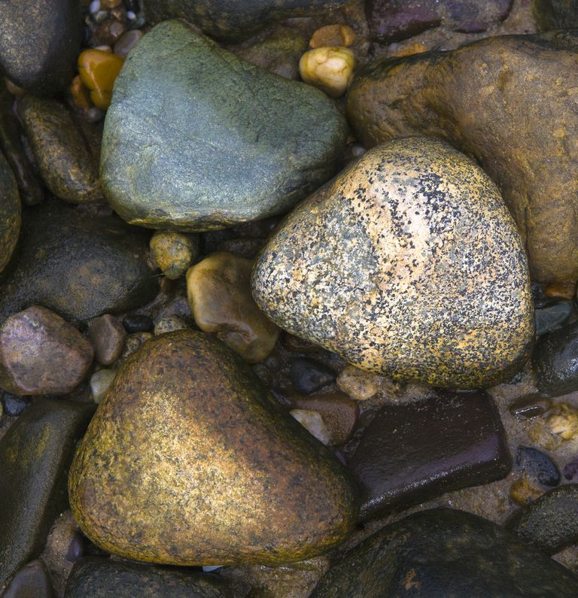

- Sediment Transport and Deposition
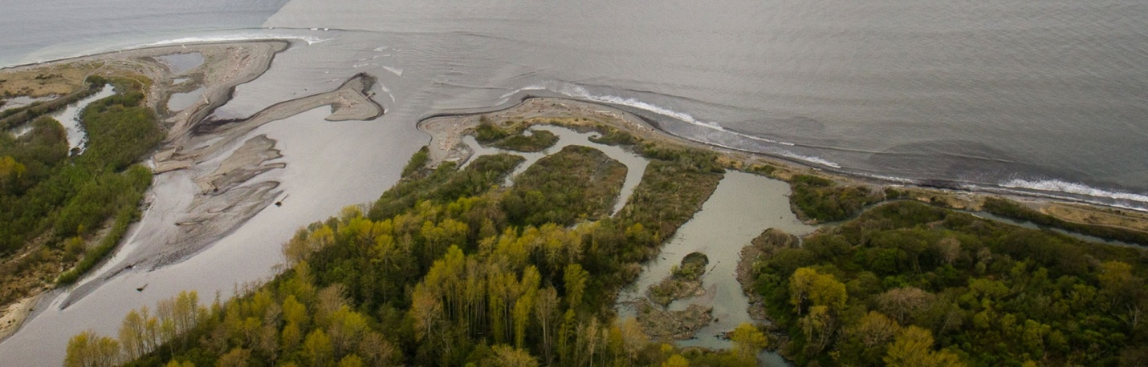
- Forms of sentiments.
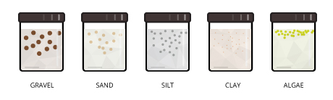

- Forms of Suspension
